Luxury boom as Bonett banks on high-end retail precincts
Billionaire property magnate Shaun Bonett is doubling down on the revamp of his luxury brands with new boutiques in Adelaide and Brisbane, where cashed-up locals and visitors await.
By JOHN STENSHOLT

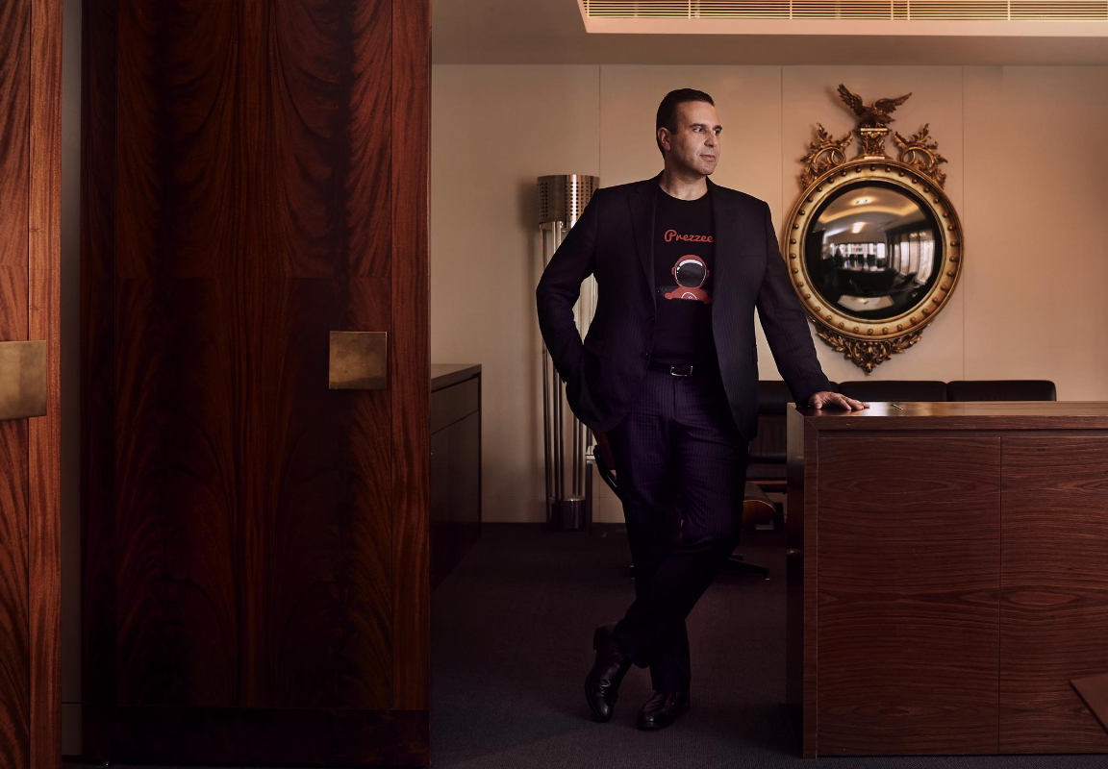
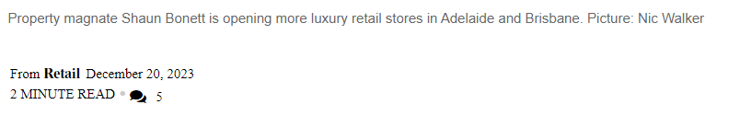

Billionaire property magnate Shaun Bonett has doubled down on the revamp of his retail assets in Adelaide and Brisbane, betting on luxury brands to meet pent-up demand from cashed-up locals and visitors.
His Precision Group has secured two key new luxury brands, one in Adelaide where The Hour Glass specialty watch group is opening at its Adelaide Central Plaza, and the other iconic Australian business Paspaley at MacArthur Central Shopping Centre in Brisbane.
Bonett said the South Australian and Queensland capital cities were increasingly attractive to luxury brands due to increase in flights from overseas and also relatively buoyant local foot traffic given both centres suffered fewer lockdowns during Covid than other states on the east coast.
“The demand for flagship boutiques is being fuelled by workers returning to CBDs and a resumption of international tourism, as retailers tap into the continued demand for experience-based, physical stores,” Bonett said.
“And what you’re finding with these big international brands is a lot of the larger countries that have fuelled their growth over the last decade, like China or Russia, are no longer doing as well. So, they’re needing to find new places, and are doubling down on jurisdictions they consider offer the greatest level of stability. Like Australia.”
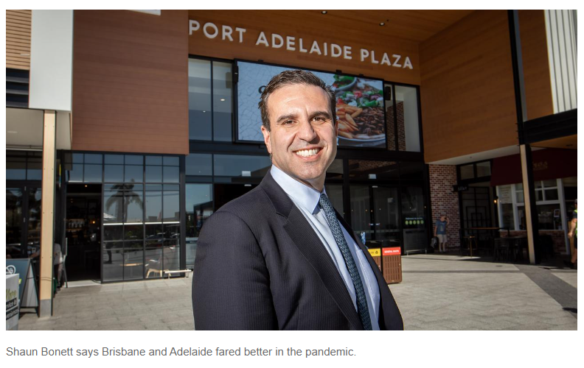
Bonett is spending about $125m over three years to develop Adelaide’s first luxury retail precinct on Rundle Mall, which has included French fashion house Louis Vuitton opening up what has been a successful temporary pop-up store.
READ MORE: Adapt or die: retailers warned of new paradigm | SA billionaire, model business partner take on Instagram | Gift keeps giving for expat billionaire Bonett |
Initial plans had the Louis Vuitton store operating until just after Christmas, a period Bonett would like parent company LVMH to extend.
In the meantime, he has struck a deal with The Hour Glass to join the likes of luxury retailers Tiffany & Co. and TAG Heuer at Adelaide Central Plaza.
“Luxury brands look to position themselves as close to their peer brands as possible. It’s all about location. That is the fundamental piece of the puzzle and is … what we are trying to deliver,” said Bonett.
Other global brands near Adelaide Central Plaza include Apple and Sephora. Breitling Oceania has also just opened its first Breitling Boutique in Adelaide’s King William Street.
Adelaide Central Plaza will be the first outlet in South Australia for The Hour Glass, and is slated to open in May 2024. The 209 sq m boutique will face Rundle Mall and showcase multiple luxury watch brands.
Meanwhile, in Brisbane Paspaley will open a flagship store at Precision Group’s MacArthur Central Shopping Centre in March 2024.
Located at the Queen Street entrance to MacArthur Central, the 229 sq m, double height facade Paspaley Boutique is being constructed from Italian stone and will be three times the size of the group’s previous Brisbane location at Queens Plaza.
The MacArthur Central luxury precinct already includes Hugo Boss, Longines and TAG Heuer.
“I don’t think we appreciate the fact enough that Adelaide, Brisbane and Perth basically avoided much of the pandemic,” Bonett said.
“So the culture there is pretty healthy and it has been preserved well and there’s an appeal to go to the CBD for their own residents, as well as attracting a higher number of tourists.
“And that is the thing about the luxury sector. International tourist numbers are increasing to these places because they are considered hidden jewels, and when they travel they tend to spend more (on luxury goods).
“And you’ve got people here who may not have mortgages now and have previously been saving for the future. Well, the future has come and suddenly they are buying these luxury items.
“There is more of a focus on that ‘now’ type mentality.”

JOHN STENSHOLT, EDITOR, THE LIST
John Stensholt joined The Australian in July 2018. He writes about Australia’s most successful and wealthy entrepreneurs, and the business of sport. Previously John worked at The Australian Financial Review.
